  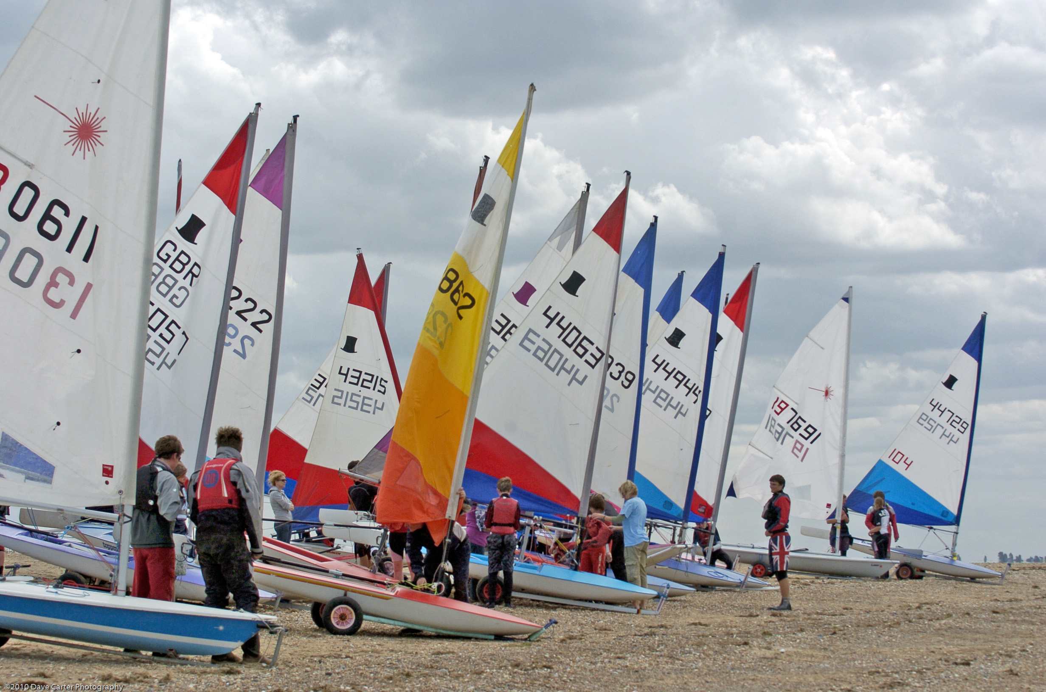
  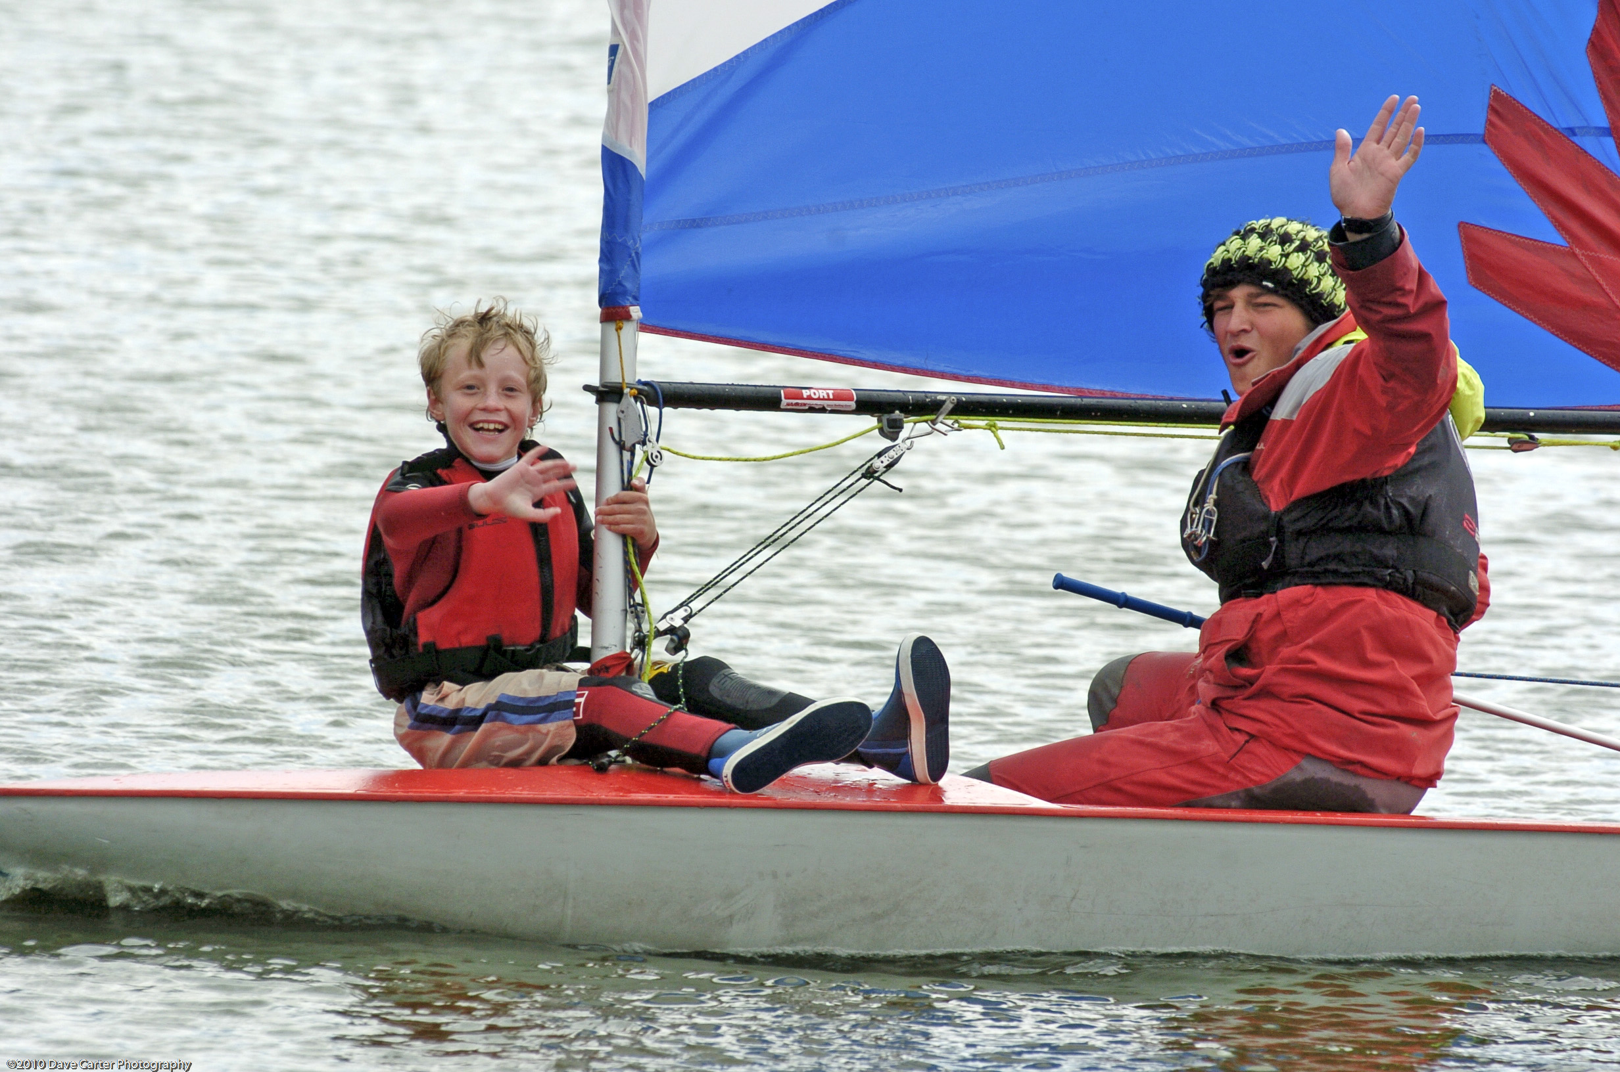
  10th May 12-5
  Sailing open day
  Sailing is an incredible sport. It’s a great way of keeping fit, meeting new people and a fantastic way to get out amongst nature. Above all sailing is FUN and there is no other sensation like gliding across the water.
  
  So whether you are new to the sport, looking to get back on the water or sail regularly, why don’t you come and visit our Sailing Club. You can have a go at sailing, see what the club has to offer and get involved. Who knows, if you visit, you might just get hooked!
  Expected to get wet !
  Bring a change of clothes
  Meet our RYA Instructors
  L
  life jackets provided
  Bar & BBQ available
  all day
  vaila
  Join on the day to receive special offers and discounts
  All Welcome
  Snettisham Beach Sailing CluB
  PE31 7RB www.snetbeach.co.uk
  Natalie Miller
  Can provide further information
  nataliemiller1000@gmail.com

